Are You Too Connected for Sleep?
Although we are recommended to sleep for at least 7-9 hours every night for optimal health outcomes and success, the Centers for Disease Control and Prevention (CDC) has found that 35.2% of adults sleep less than 7 hours a night. We are often so connected to our technology devices, unable to disconnect from our professional pursuits, our minds are always racing, and there are so many competing priorities that we may struggle with obtaining a good night’s rest.

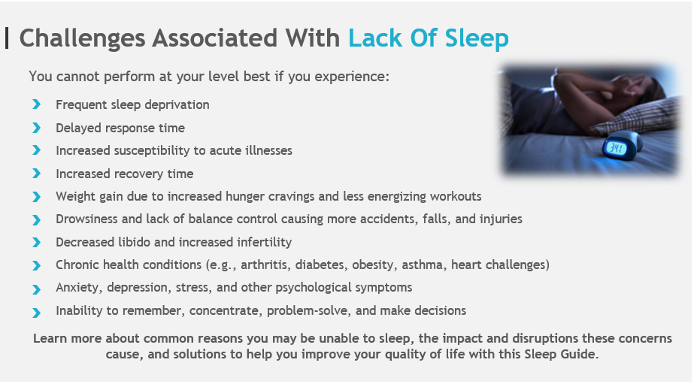
What’s
Your
Chronotype? 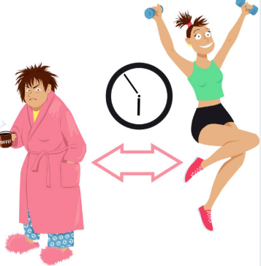
Unleash your ultimate success by learning more about what kind of sleeper you are with
Dr. Michael Breus’ Sleep Chronotype Quiz

Learn to work with your body’s natural programming, rather than against it. Discover your Chronotype to unlock your power to know when to do everything for the optimum results.

Why You Have Trouble Sleeping at Night
Lack of Sleep Concern | What Your Sleep May Look Like | Daily Routine Impact | Solutions to Improve Quality of Sleep
Racing Mind  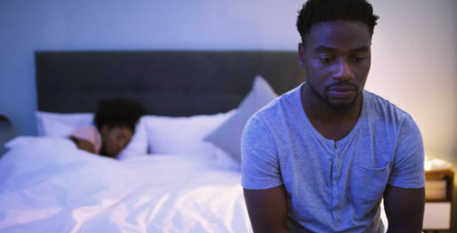 | Racing mind.  Constant worry about past, present, and future events.  Tossing and turning. | Increased stress levels due to continuous “flight or fight mode”. | Meditation or Yoga to quiet negative thoughts and lowers stress levels. Gratitude works by tricking your brain into focusing on positive outcomes.  Writing in a journal everyday takes negative thoughts out of your mind, puts them on paper, and helps ease the mind by creating a checklist and a way to tackle problems one step at a time.  Healthy Diet/Lifestyle means no large meals before bed because you may be causing your body unnecessary stress by consuming foods that are not nutritious.  Exercise is a great stress reducer and puts the body in a relaxed state, which helps the transition into an evening sleep routine.
Evening Buzz | Difficulty falling asleep.  Restlessness throughout  the night. | High caffeine intake or exercise late in the day makes it difficult to wind down in the evening. | Regulate Caffeinated Beverages by strictly avoiding them during the mid-afternoon.  Workout early, as exercising late in the day can cause difficulty in winding down.  Establish a relaxing evening routine to include meditative breathing, a calming bath, and chamomile tea.
Modern Disconnect with Natural Rhythms  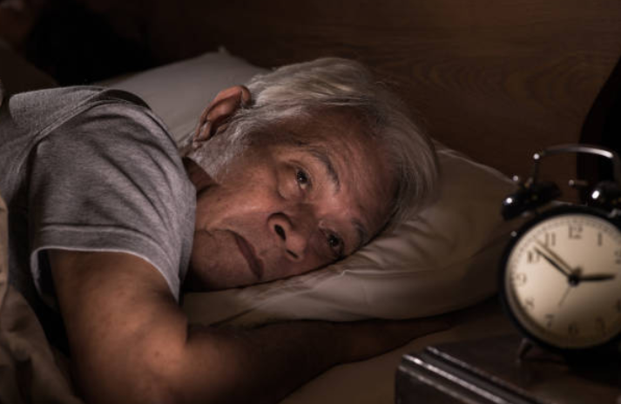 | Restlessness.  Low energy.  Nodding off during  the workday. | Time-saving devices and other human-made items that work to keep you always connected end up interfering significantly with your body’s natural sleep pattern. | Make the bedroom as dark as possible by using blackout curtains or taping existing curtains to the wall to block out light.  Keep the temperature relatively cool since your brain is most effective during its “active” time of day while you are asleep. This can also be achieved with the help of a “Chilipad”.
Too Connected to Technology  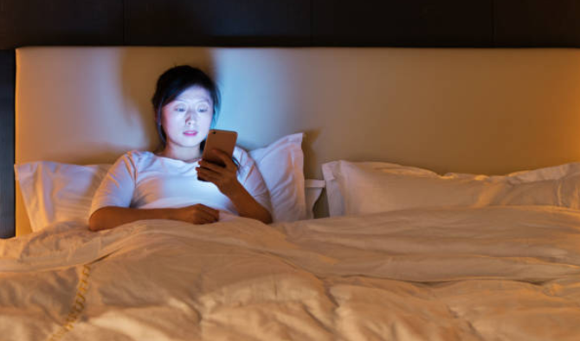 | Restlessness and waking up throughout the night as distracted by scrolling through your phone, computer, or other devices before going to bed. | Artificial light production from these devices sends mixed signals to our brains and causes confusion about day and night. | Avoid temptations to scroll by turning off your devices at least one hour before going to sleep.  Try wearing blue-light blocking glasses to wear if you are exposed to artificial lights during a late workday.
Night Owl | Staying up late to watch a show even when you are exhausted. | Established cortisol cycles in the brain cannot work properly if you are awake, leading to you feeling extra tired and groggy the next day. | Make sure you are asleep by 11:00 p.m. every night. This is the time when your brain’s cortisol surge reaches its highest peak.  Do not ignore your body’s cues. If you feel tired, you should go to sleep.  Find out what kind of sleeper you are by taking the Chronotype Sleep Quiz.
Waking Up in the Middle of the Night  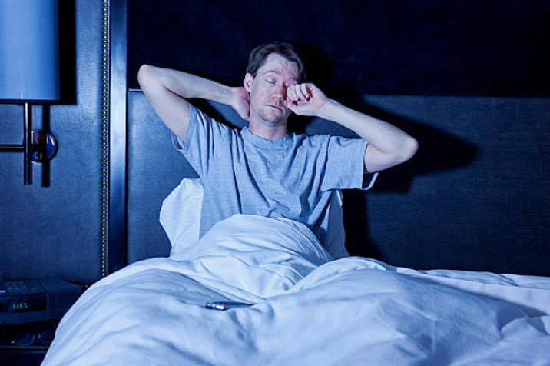 | You are awake before it’s time for the day to begin and have great difficulty falling back asleep. | When you are awake instead of sleeping, your brain cannot complete the necessary tasks for when it’s hard at work. | Avoid alcohol as a tactic for falling asleep. While you may fall asleep initially, the alcohol metabolizes and causes a spike and crash effect on your blood sugar.  An essential oil blend can have a wonderfully calming effect while you sleep. Lavender, rose, and bergamot oils are known for their sleep-inducing properties.
Consider the Following Tools to Help You Improve Your Quality of Sleep
Tools of the Trade for Better Sleep
Tips from Nick Littlehales’s Sleep Recovery Strategy for Elite Athletes
According to Nick Littlehale, although we may not have control over what happens during sleep, we do have control over the actions we take when we are awake to improve the quality of our sleep. Nick Littlehale works with elite athletes around the world to ignite game-changing sleep and a faster personalized route to recovery. He has found that by sleeping 2 hours less each day than recommended for 14 days, you will reduce your cardiovascular performance by 11% and the body’s metabolism of glucose by 30%-40%.
Important Game-Changing Sleep Tips:
- Ensure you understand your Circadian Rhythm
- Identify your personal Chronotype and Personal Sleep Profile to implement a combination of interventions that would work best for your body
- Wakeup at the same time every morning
- Take a recovery break every 90 minutes to soak in daylight and digest information
- Ensure your sleep room is your “recovery room” for mental and physical recovery
- Cut off Screen Time at least 30 minutes before naps
- Don’t Eat before napping
- Don’t Force yourself to nap
- Establish a Nap Ritual
- Avoid Alcohol or Sedatives to fall
asleep
- Monitor daily Habits that cause sleep interruption with a Tracking Device
- Sleep more comfortably on an incline by Raising the Head of Your Bed
- Rest and relax with Yoga Nidra Routine
- Increase your intake of Magnesium (a Melatonin source) and Vitamin D
- Listen to Binaural Beats to slow brainwaves
- Alleviate your worries and relax with a soothing essential oil and oil diffuser
- Ground your sleep with products that stimulate Ground Therapy

Consider The Following Ideas To Ensure You Get The Most Out Of Your Afternoon Nap:
Optimize Your Nap For the
Ultimate Relaxation
- Don’t use an Alarm Clock unless
absolutely necessary
- Time your nap
- Avoid Coffee and other Caffeinated
- Beverages before napping
- Avoid Stress a few hours before naps
- Avoid Exercise before napping.

